Department of Electrical & Computer Engineering (ECE), Florida Institute of Technology, Melbourne, Florida

Voice Controlled Robot



ECE 5527 – Search & Decoding

14th December

By: Adolf A D’costa Prof: Dr. Veton Kepuska

ID: 9035384040



Index

1. Introduction…………………………………………………………………………...3
2. Components…………………………………………………………………………...3
3. Robot Frame…………………………………………………………………………..5
4. 1 Shield…………….………………………………………………………………….6
5. 1 Shield Schematic….……………………………………………………...…………7
6. DC motor specification………………………………………………………...……..8
7. L298N Motor Driver…………………….…………………………………………....9
8. Circuit Diagram……………………………………………………………………...10
9. Schematic Diagram………………………………………………………………….11
10. PCB Sketch………………………………………………………………………….12
11. System Commands…,.………………………………………………………………13
12. Code…………………………………………………………………………………14
13. Cost....….……………………………………………………………………………16
14. Application …………………………………………………………………………17
15. Reference……………………………………………………………………………18



Introduction

The goal of this project was to develop a 4WD, voice-controlled Robot that is portable and has a range of about 100 meters. Speech recognition technology has become increasingly popular concept in the recent years. One of the most important advantage of the system is that it does not require the user to be trained, it is a skill that we obtain since we are children. Speech recognition is also flexible to different languages. User can give a command in any language.

The System use the mobile phone to take a voice input and transmit it wirelessly by Bluetooth. It uses low power Bluetooth technology that is Bluetooth 4.0. Dictating is, on average, three times faster than typing.

Speech recognition is the inter-disciplinary sub-field of computational linguistics that develops methodologies and technologies that enables the recognition and translation of spoken language into text by computers. Some system needs to be trained while others don’t have to be trained., which distinguish them into speaker dependent and speaker independent.

Components

* Arduino Uno --

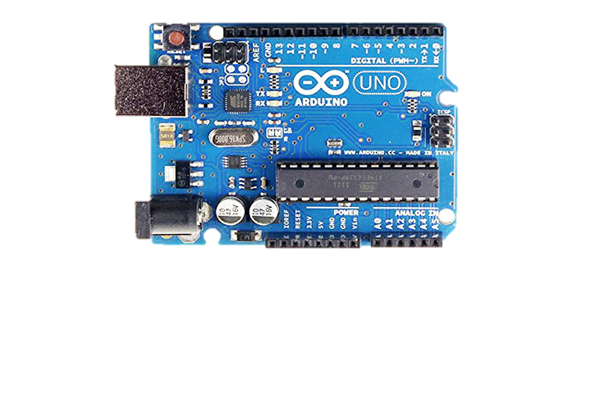



* Robot Frame --

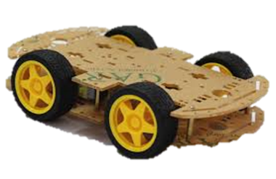

* 1Sheeld --

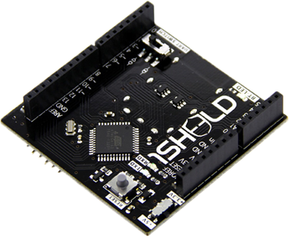

* DC Motor (4 pieces) --

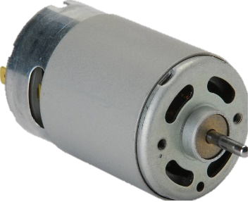



Robot Frame

* Material: ABS
* Package Included
* 2 x Car chassis
* 4 x Gear Motor (1: 48)
* 4 x Speed encoder
* 8 x Fasteners   
     
    
   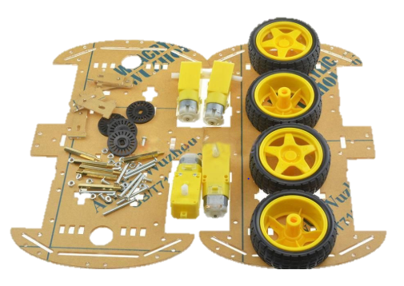

Note: The measurement allowed error is +/- 1-3cm.



1 Sheeld

1Sheeld is an Arduino Sheeld which is used connect the smart phone to the Arduino through Bluetooth 4.0. All the peripherals on the phone can be used and interfaced with the Arduino.

Examples – Accelerometer, light sensor, mic, speaker, display, etc.

Supported Arduino Boards - (Uno , MegaADK,Mega2560, Leonardo)

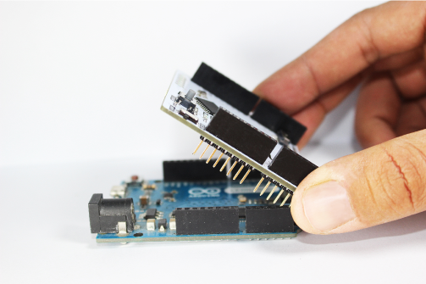 

Note - 1Sheeld+ based on a BLE “Bluetooth Low Energy” technology which is supported only by devices that has Bluetooth 4



1 Sheeld Schematic

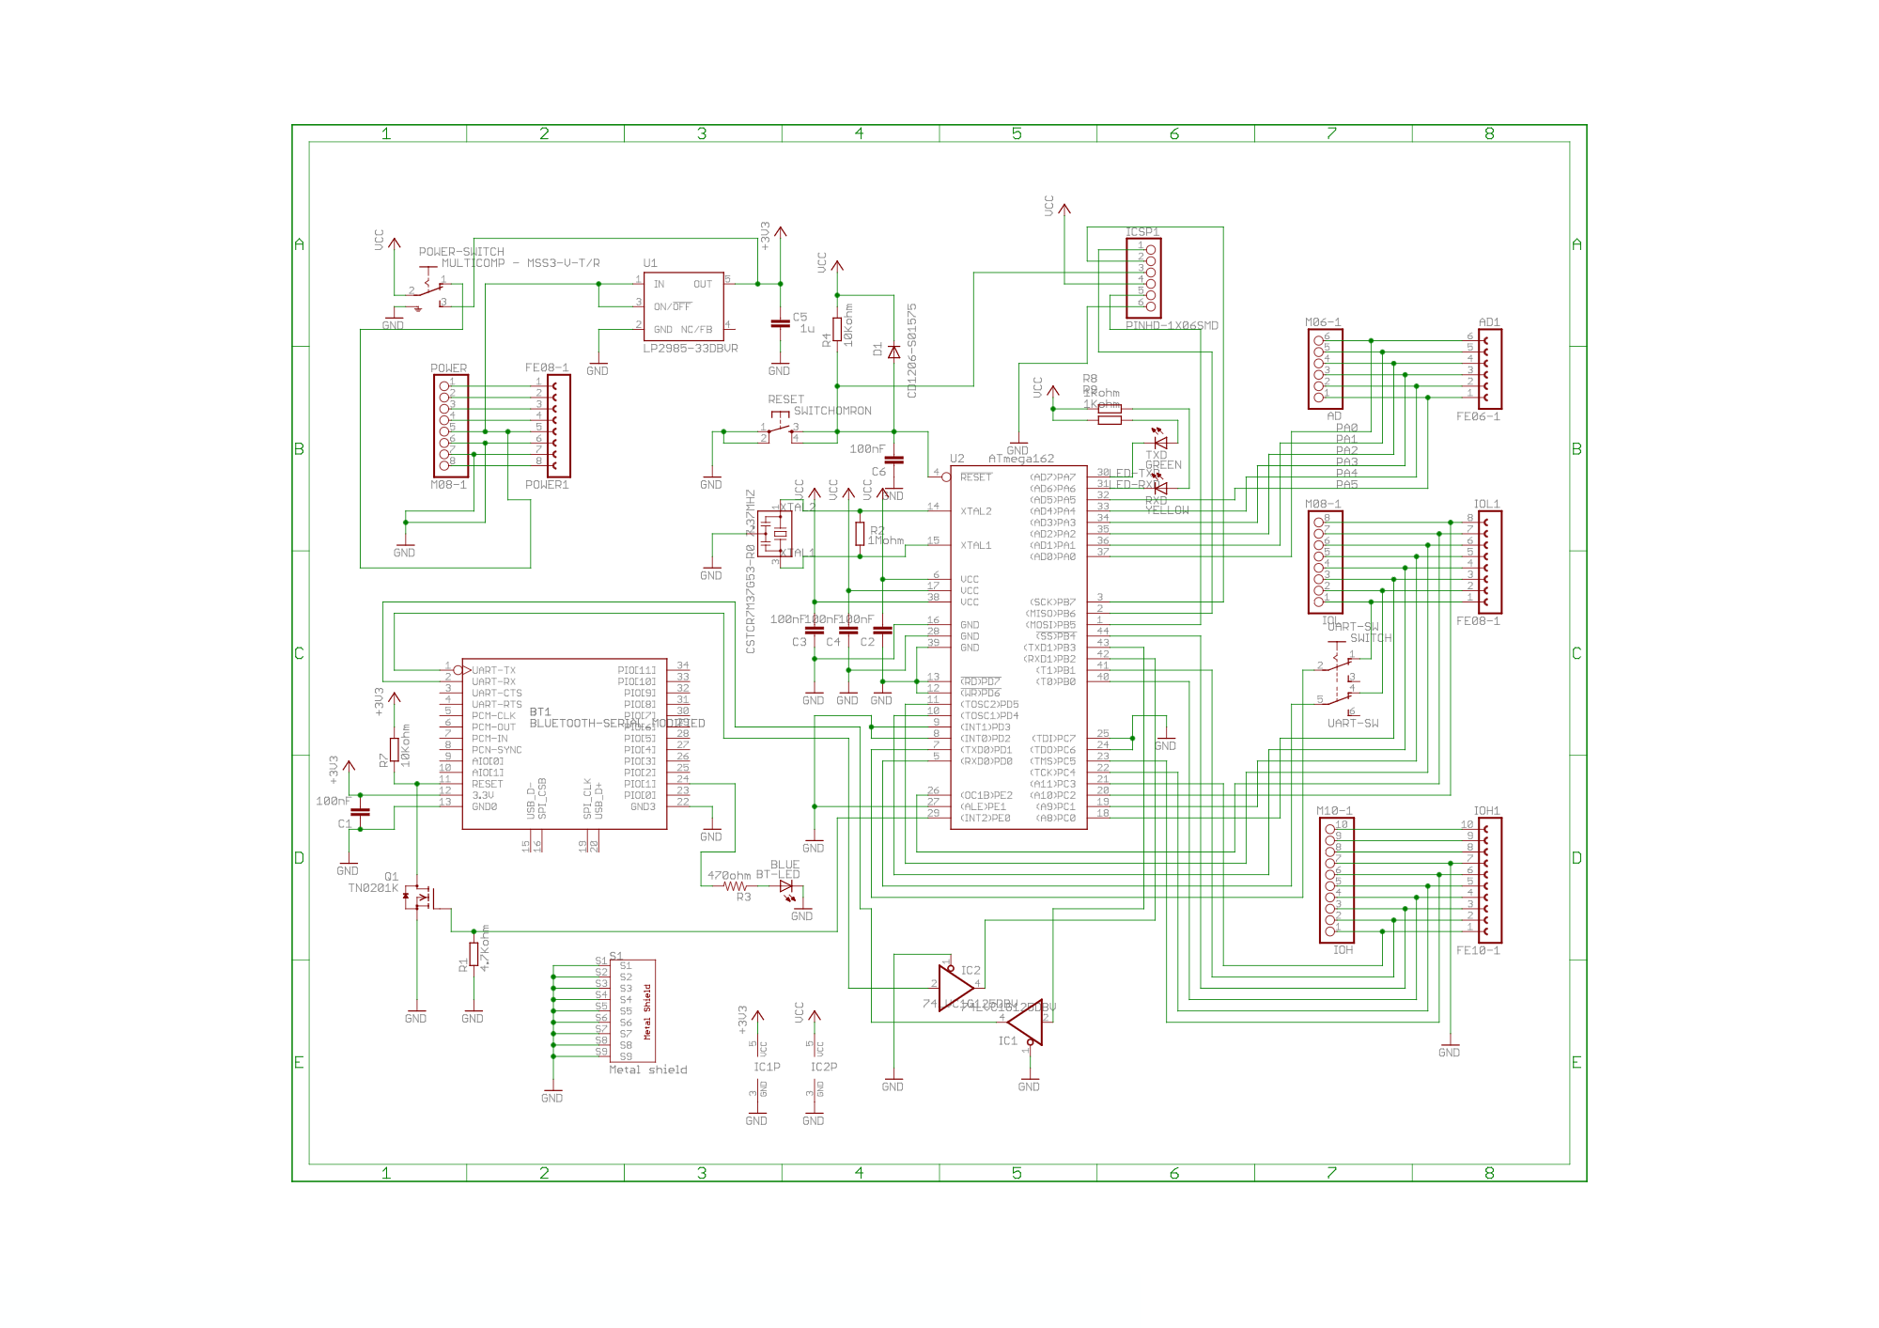



DC Motor Specification

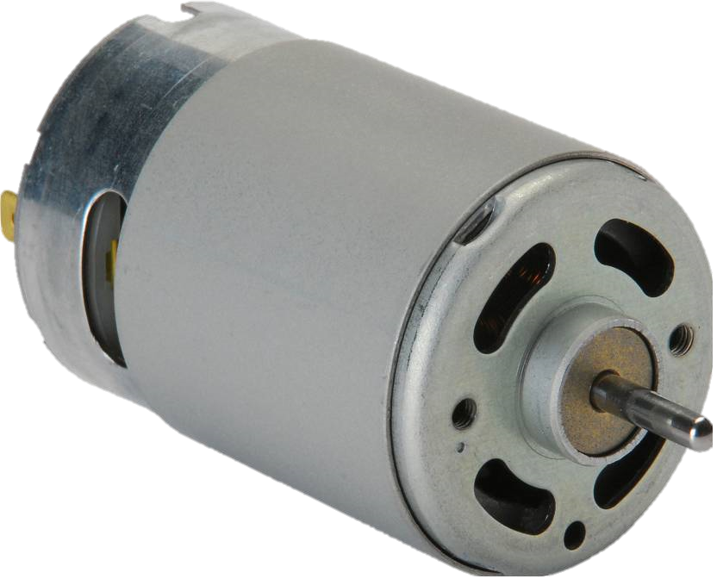

* 2400 RPM
* 360 Degree Revolution
* 3Volt to 9Volt operation Voltage
* Stall Torque 36 g.cm without gear system
* 115mA current draw

A gear system was added to the motor, to convert the high rpm of the motor into higher torque which can drive the robot vehicle.



L298N Motor Driver

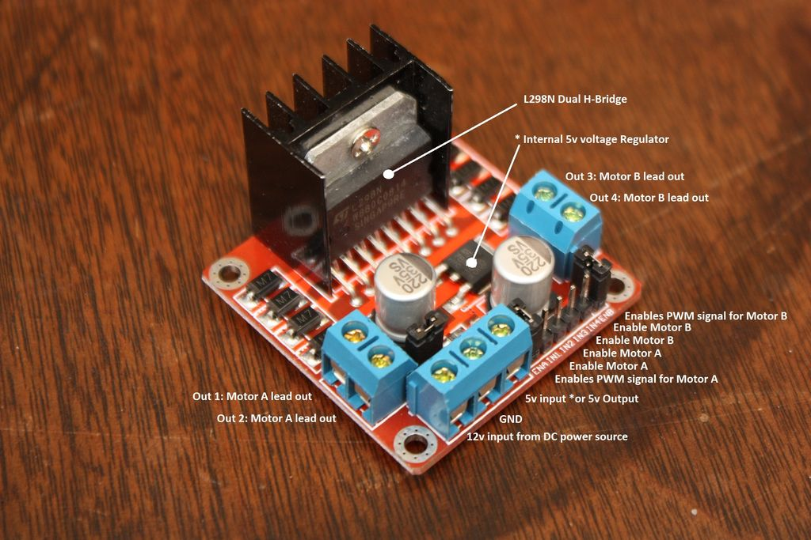

* Double H bridge Drive Chip: L298N
* Logical voltage: 5V Drive voltage: 5V-35V
* Logical current: 0-36mA Drive current: 2A (MAX single bridge)
* Max power: 25W
* Dimensions: 43 x 43 x 26mm
* Weight: 26g



Circuit Diagram

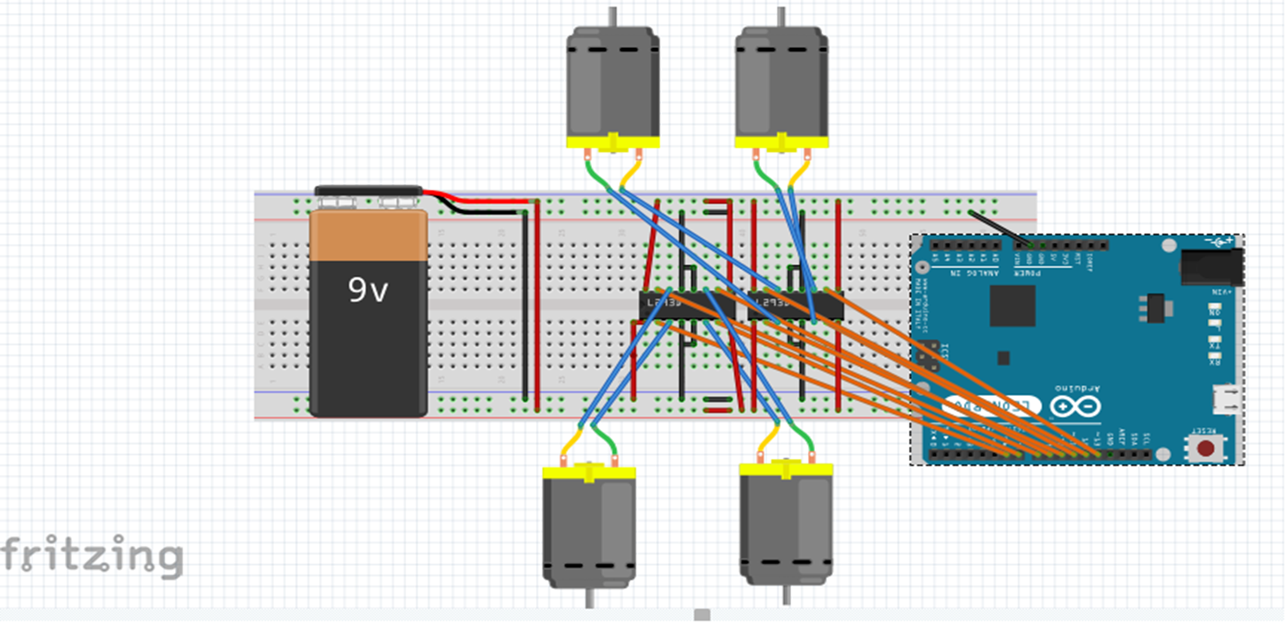

Note that the (1Sheeld) sheeld must be placed above the Arduino for the interface with the smart phone.



Schematic Diagram



PCB Sketch



System Commands

Stop –

Stops the Vehicle

Left –

Moves the vehicle Left for 2 sec

Right –

Moves the vehicle Right for 2 sec

Front -

Moves the vehicle Front for 2 sec

Back –

Moves the vehicle Back for 2 sec



Code

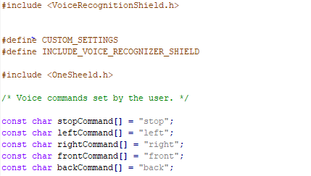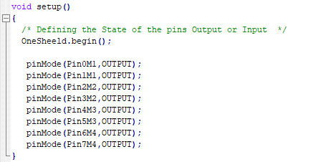

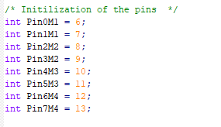





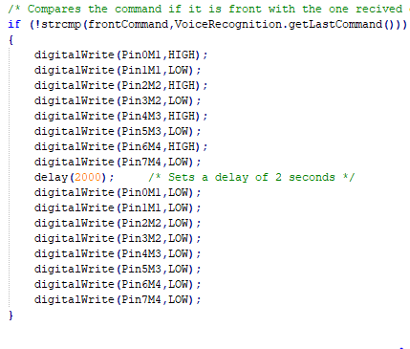



Cost



* Robot Frame = 15$
* 1 Sheeld = 30$
* Arduino Board with sensors = 30$
* Motor Driver L298N = 8$
* Total Project cost = 83$



Application

Mine Detection ---

Prevent putting humans in the line of fire where there could be explosion.

Hazardous location ---

Prevent putting humans in the line of fire due to toxic fumes or chemicals

Fire Fighting ---

Easy to deploy and has a range of 70 – 100 Meters.

Search and rescue ---

Gives access in confined spaces for search and rescue.



Reference

1. <https://1sheeld.com/downloads/> (For 1Sheeld App)
2. <https://1sheeld.com/downloads/> (For Library)
3. <https://www.arduino.cc/en/Main/Software> (For Arduino IDE and Usb driver)
4. https://www.sestek.com/2014/11/the-advantages-of-speech-recognition-technology/
5. www.fritzing.com
6. https://en.wikipedia.org/wiki/Speech_recognition